*Florida International University*

*School of Computing and Information Sciences*

CIS 4911 - Senior Capstone Project

Software Engineering Focus

Final Deliverable

Project Title: Smart Buildings 5.0 (DRAMA)

**Team Members:**

Roberto Murillo

Yonicel Leyva

**Product Owner(s)**:

Ali Mostafavi

**Mentor(s)**:

Ali Mostafavi

**Instructor**: Masoud Sadjadi

The MIT License (MIT)

Copyright (c) *2016 Florida International University*

Permission is hereby granted, free of charge, to any person obtaining a copy of this software and associated documentation files (the "Software"), to deal in the Software without restriction, including without limitation the rights to use, copy, modify, merge, publish, distribute, sublicense, and/or sell copies of the Software, and to permit persons to whom the Software is furnished to do so, subject to the following conditions:

The above copyright notice and this permission notice shall be included in all copies or substantial portions of the Software.

THE SOFTWARE IS PROVIDED "AS IS", WITHOUT WARRANTY OF ANY KIND, EXPRESS OR IMPLIED, INCLUDING BUT NOT LIMITED TO THE WARRANTIES OF MERCHANTABILITY, FITNESS FOR A PARTICULAR PURPOSE AND NONINFRINGEMENT. IN NO EVENT SHALL THE AUTHORS OR COPYRIGHT HOLDERS BE LIABLE FOR ANY CLAIM, DAMAGES OR OTHER LIABILITY, WHETHER IN AN ACTION OF CONTRACT, TORT OR OTHERWISE, ARISING FROM, OUT OF OR IN CONNECTION WITH THE SOFTWARE OR THE USE OR OTHER DEALINGS IN THE SOFTWARE.

***Abstract***

*This document presents the information necessary to gain a good understanding of Smart buildings 5.0 (DRAMA) how creates a tool for users in danger after a natural disaster. You will be presented with an introduction, set of user stories, project plan, system design, system validation, glossary, and appendix.*

**Table of Contents**

**Introduction** ………………………………………………………………………………………………………………………….5

Current System …………………………………………………………………………………………………………………....5

Purpose of New System …………………………………………………………………………………….…………………..5

**User Stories**

Implemented User Stories …………………………………………………………………………………...……………....6

Pending User STORIES …………………………………………………………………………………………………............31

**Project Plan**

Hardware and Software Resources ……………………………………………………………………………………..32

Sprints Plan ………………………………………………………………………………………………………………………..34

*Sprint 1* ………………………………………………………………………………………………………………………...... 34

*Sprint 2* …………………………………………………………………………………………………………………………... 35

*Sprint 3* …………………………………………………………………………………………………………………………... 37

*Sprint 4* …………………………………………………………………………………………………………………………... 39

*Sprint 5* …………………………………………………………………………………………………………………………... 40

**System Design**

Architectural Patterns ……………………………………………………………………………………………………....42

System and Subsystem Decomposition ……………………………………………………………………………………43

Deployment Diagram ……………………………………………………………………………………………………………44

Design Patterns …………………………………………………………………………………………………………………..45

**System Validation**  ………………………………………………………………………………………………………………...**..**46

**Glossary**  …………………………………………………………………………………………………………………………………62

**Appendix**  ………………………………………………………………………………………………………………………………**…**63

Appendix A - UML Diagrams …………………………………………………………………………………………………..63

*Static UML Diagrams*  ……………………………………………………………………………………………………….*..*63

*Dynamic UML Diagrams*  …………………………………………………………………………………………………..*..69*

Appendix B - User Interface Design ………………………………………………………………………………………98

Appendix C - Sprint Review Reports ……………………………………………………………………………………111

Appendix D - Sprint Retrospective Reports …………………………………………………………………………115

**References** ……………………………………………………………………………………………………………………...……11**8**

# 

# Introduction

You will provided with a rundown of the current problem and how it influenced the features for Smart Buildings 5.0 (DRAMA) followed by a description of what the purpose or goal of the web application and how it will solve our problem.

After this section we will cover implemented User Stories, Project Plan, System Design, Validation and, glossary.

## Current System

Persons, who want to get information about a disaster area or want to help, have very limited tools to do it. Normally the information that they can get is what is being shown in the news. The news TV channels cannot get access to every single area, so what they show is an overview of what is really happening. It is not known immediately what the affected persons really need or how to deliver the resources because in some places the streets are blocked. Moreover, there are civil engineers around the world that can volunteer to assess damages, but they cannot go to the country of the natural disaster to evaluate all the buildings.

## Purpose of New System

Our application consist in getting information from affected area with the help of users called (Mappers). We show helpful information to help agencies distribute their resources accurately and faster. Everywhere around the world there will be available volunteers with expertise in civil engineering that will help to evaluate the conditions of the buildings. Our application provides statistics so that agencies such as red cross can supply resources to the most affected area.

# 

# User Stories

The following section provides the detailed user stories that were implemented in this iteration of the Smart Buildings (DRAMA) project. These user stories served as the basis for the implementation of the project’s features. This section also shows the user stories that are to be considered for future development.

## Implemented User Stories

**User Story #871 – Register User**

As a user I want to be able to register so that I can be able to use the site features.

Acceptance Criteria

1. User must enter first and last name, email, password, and role.
2. User should be granted immediate access upon registration.
3. No user can register twice.

**Use Case**

|  |  |
| --- | --- |
| Use Case ID | SB_RegisterUser_01 |
| Details | User creates an account to be able to log in to the system. |
| Actors | User |
| Preconditions | 1. The server and application are up and running 2. User does not have an account registered in the system |
| Description | 1. Use case begins when user chooses the register option under the login form. 2. The system displays a data entry form for creating an account. 3. The user should enter the following data: First name, Last Name, password, confirm password, email, and role. 4. After completing the form, the user should click on the “Submit” button. 5. The system verifies that the email has not been previously registered, and that all fields are filled. 6. Once the system validates the information, an account will be created for the user. 7. Use case ends when system redirects a successfully registered user into the website menu. |
| Post-Conditions | 1. The number of user accounts is registered by one. 2. The user account has been saved in the system. |
| Alternative Course of Action | 1. User has the option to cancel an account creation by going back to the previous page or by closing the browser. |
| Related Use Cases | None |
| Decision Report: | |
| Frequency | Any number of accounts are created every day |
| Criticality | High. Users have to create accounts in the system so that they can login, thus access the website features. |
| Risk | Medium. Implementing this use case employs standard web-based and database technology. |
| Modification History: | |
| Owner | Yonicel Leyva |
| Initiation Date | 5/20/16 |
| Date Last Modified | 6/5/16 |

**User Story #872 – Login User**

As a user I want to be able to log in to the website so that I use the website features.

Acceptance Criteria

1. The user’s email and password are the only credentials to login.
2. The system must be able to corroborate the credentials and respond appropriately.
3. The user must stay in the login view if credentials entered are wrong.

**Use Case**

|  |  |
| --- | --- |
| Use Case ID | SB_LoginUser_02 |
| Details | User uses credentials to get access to the system. |
| Actors | User |
| Preconditions | 1. The server and application are up and running 2. User has an account registered in the system |
| Description | 1. Use case begins when user opens the login page. 2. The user shall enter the following data: login email and login password. (All the fields are required) 3. The user shall then send the login request by selecting the login button. 4. The use case ends when the user is logged in to the system |
| Post-Conditions | 1. The login authentication request has been saved in system and the user session has been instantiated. |
| Alternative Course of Action | 1. User has the option to cancel an account creation by going back to the previous page or by closing the browser. |
| Related Use Cases | None |
| Decision Report: | |
| Frequency | On average 1.5 requests are made by the user per application execution. |
| Criticality | High. Allows the user to log into the system. |
| Risk | Medium. Implementing this use case employs standard web-based and database technology. |
| Modification History: | |
| Owner | Roberto Murillo |
| Initiation Date | 5/20/16 |
| Date Last Modified | 6/5/16 |

**User Story #885 – View/Edit Profile**

As the user I would like to open my profile page to view my personal information.

Acceptance Criteria

1. The user must be able to view their personal information.
2. All changes will be effected immediately when user successfully submit the changes.

**Use Case**

|  |  |
| --- | --- |
| Use Case ID | SB_ViewEditProfile_03 |
| Details | User clicks on the profile link to view their information |
| Actors | User |
| Preconditions | 1. The server and application are up and running. 2. The user must be logged in to the system. |
| Description | 1. Use case begins when user chooses the click on the profile link under their name. 2. The system displays a data form showing user information. 3. The user can choose or replace their profile picture. 4. The user can choose to edit their information. 5. The use case ends when the user clicks on the “Save” button. |
| Post-Conditions | 1. The user account has been updated in the system. |
| Alternative Course of Action | 1. User has the option to cancel any changes made by going back to the previous page or by closing the browser. |
| Related Use Cases | None |
| Decision Report: | |
| Frequency | The user can change or view their profile as much as they want. |
| Criticality | Low. It is an optional functionality for users to personalize their account. |
| Risk | Medium. Implementing this use case employs standard web-based and database technology. |
| Modification History: | |
| Owner | Yonicel Leyva |
| Initiation Date | 6/7/16 |
| Date Last Modified | 6/7/16 |

**User Story #888 – View home page with google maps**

As the user I would like to open, check the map and look at my location.

Acceptance Criteria

1. The user must be able to view the map and find their location.

**Use Case**

|  |  |
| --- | --- |
| Use Case ID | SB_ViewHome PageWithMap_04 |
| Details | User clicks on the login button to view the map |
| Actors | User |
| Preconditions | 1. The server and application are up and running. 2. The user must be logged in to the system. |
| Description | 1. Use case begins when user click on the login button. 2. The system displays the map in a specific point. 3. The system will ask the users if they want to share their location. 4. If the user say yes to the share location question the map will show the user their location in the map. |
| Post-Conditions | 1. The users will see the map and can navigate in it. 2. If they want to see their location, they will be able to see it in the map and navigate around the map. |
| Alternative Course of Action | 1. Users decline sharing their location so they will see our specific point in the map and can navigate. |
| Related Use Cases | None |
| Decision Report: | |
| Frequency | The user can open the home page every time they want and check their location. |
| Criticality | High. It is most important page in the project because here is where users can post the assessment. |
| Risk | Medium. Implementing this use case employs standard web-based and database technology. |
| Modification History: | |
| Owner | Roberto Murillo |
| Initiation Date | 6/7/16 |
| Date Last Modified | 6/13/16 |

**User Story #890 – Create Building Report**

As a user I would like to report an assessment about my building for others to see.

Acceptance Criteria

1. The user must be able to fill out basic information about their building.
2. The user must be able to upload pictures of their building.

**Use Case**

|  |  |
| --- | --- |
| Use Case ID | SB_CreateBuildingAssesment_05 |
| Details | User clicks on the “Create assessment” link to to start the report |
| Actors | User |
| Preconditions | 1. The server and application are up and running. 2. The user must be logged in to the system. |
| Description | 1. Use case begins when user chooses the click on the “Create report” link on the navigation bar. 2. The system displays a data form showing information the user will fill out. 3. The user clicks on the “Next” button at bottom of the form to continue. 4. The system will display a form allowing user to upload pictures. 5. The user can choose to browse for photos to upload or take photos if they are on a mobile phone. 6. The use case ends when the user clicks on the “Complete” button. |
| Post-Conditions | 1. A user assessment report has been created in the system. |
| Alternative Course of Action | 1. User has the option to cancel any changes made by going back to the previous page or by closing the browser. |
| Related Use Cases | None |
| Decision Report: | |
| Frequency | The user can create multiple assessments based on their GIS location. |
| Criticality | High. It is an crucial functionality for users to create assessments so that others can evaluate. |
| Risk | Medium. Implementing this use case employs standard web-based and database technology. |
| Modification History: | |
| Owner | Yonicel Leyva |
| Initiation Date | 6/13/16 |
| Date Last Modified | 6/13/16 |

**User Story #904 – Reset Password**

As a user I would like to reset my forgotten password so that I can access my account.

Acceptance Criteria

1. The user should be able to reset their password, so they can login in the app again.

**Use Case**

|  |  |
| --- | --- |
| Use Case ID | SB_Reset Password_06 |
| Details | User clicks on reset password button |
| Actors | User |
| Preconditions | 1. The user must be registered. 2. The user have to remember the e-mail that he used to register |
| Description | 1. Use case begins when user click on the forgot Password button. 2. The system will ask for the user to input the e-mail used during registration. 3. If it is correct the user will receive an email with a link to reset the password. 4. The user will create a new password. |
| Post-Conditions | 1. The user will be able to login again |
| Alternative Course of Action |  |
| Related Use Cases | None |
| Decision Report: | |
| Frequency | Depends of the user memory to remember the passwords |
| Criticality | Low, because normally user save their passwords in the browsers. |
| Risk | High, Implementing this use case employs standard web-based and database technology. |
| Modification History: | |
| Owner | Roberto Murillo |
| Initiation Date | 6/13/16 |
| Date Last Modified | 6/18/16 |

**User Story #891 – View Map Marker**

As a user i would like to see map markers on the map so that I can view the reported assessment from that location.

Acceptance Criteria

1. The user must be able to view markers layout out on map.

**Use Case**

|  |  |
| --- | --- |
| Use Case ID | SB_ViewMapMarker_07 |
| Details | User clicks on a marker on the map to view report information |
| Actors | User |
| Preconditions | 1. The server and application are up and running. |
| Description | 1. The use case begins when the user navigates to home page 2. The user clicks on a marker loaded on the map 3. The user views a basic information about the report 4. The use case ends when the user clicks on “View Assessment” |
| Post-Conditions | 1. None. |
| Alternative Course of Action | 1. User has the option to cancel any changes made by going back to the previous page or by closing the browser. |
| Related Use Cases | None |
| Decision Report: | |
| Frequency | The user can view the markers on the map as much as they want. |
| Criticality | High. It is a crucial functionality for a user to view an assessment on the map. |
| Risk | Medium. Implementing this use case employs standard web-based and database technology. |
| Modification History: | |
| Owner | Yonicel Leyva |
| Initiation Date | 6/20/16 |
| Date Last Modified | 6/20/16 |

**User Story #908 – View assessment report**

As a user I would like to see the report for the assessment so that I can have a better view of the conditions of the building and the specific needs that people have.

Acceptance Criteria

1. The user must be able to view the report.

**Use Case**

|  |  |
| --- | --- |
| Use Case ID | SB_ViewAssessmentReport_10 |
| Details | View all the details of the assessment as a easy to read report |
| Actors | User |
| Preconditions | 1. The server and application are up and running. |
| Description | 1. The use case begins when the user navigates to home page 2. The user clicks on any marker 3. A modal form is displayed 4. The user clicks on the “Report button. |
| Post-Conditions | 1. The report view page shows all the information collected by the mapper in that specific point. |
| Alternative Course of Action |  |
| Related Use Cases | None |
| Decision Report: | |
| Frequency | The user can view every report as much as they want. |
| Criticality | Hi. according to evaluate the user (evaluator) needs to use the report so they have an idea in that specific point before evaluating. |
| Risk | Medium. Implementing this use case employs standard web-based and database technology. |
| Modification History: | |
| Owner | Roberto Murillo |
| Initiation Date | 6/27/16 |
| Date Last Modified | 7/1/16 |

**User Story #914 – Evaluate report**

As a user I would like to evaluate an assessment so that I can contribute to the community

Acceptance Criteria

1. The user must be able to select between 3 options to evaluate report.
2. The only user that can evaluate are evaluators

**Use Case**

|  |  |
| --- | --- |
| Use Case ID | SB_EvaluateAssessmentReport_11 |
| Details | Give a evaluation according to the information in the report |
| Actors | User |
| Preconditions | 1. The server and application are up and running. 2. The user have to sign in 3. The user have to be an evaluator |
| Description | 1. The use case begins when the user navigates to the report page. 2. The user selects the condition of the building 3. The user clicks on the “Evaluate” button. |
| Post-Conditions | 1. It will show a label that the evaluation was completed |
| Alternative Course of Action |  |
| Related Use Cases | None |
| Decision Report: | |
| Frequency | The user can view many reports and evaluate all of them. |
| Criticality | Hi. the user (evaluator) needs to evaluate as much report they can so, they contribute more with the society. |
| Risk | Medium. Implementing this use case employs standard web-based and database technology. |
| Modification History: | |
| Owner | Roberto Murillo |
| Initiation Date | 6/27/16 |
| Date Last Modified | 7/1/16 |

**User Story #917 – Filter Map Markers**

As a user I would like to filter map marker so that i can view the building assessments that are of interest to me.

Acceptance Criteria

1. The user must be able to view the home page map with filtered markers.

**Use Case**

|  |  |
| --- | --- |
| Use Case ID | SB_ViewMapMarker_08 |
| Details | User filters map markers on the home page to view assessments that are of interest |
| Actors | User |
| Preconditions | 1. The server and application are up and running. |
| Description | 1. The use case begins when the user navigates to home page 2. The user clicks on “Filter” button 3. A modal form is displayed to be filled 4. The user can choose to filter by: Electricity, Water, Road Access, Telecommunication, Food, Sanitation, First Aid, Shelter, or Images. 5. The use case ends when the user clicks on “Filter” to submit form. |
| Post-Conditions | 1. The home page map is refreshed with filtered markers. |
| Alternative Course of Action | 1. User has the option to cancel any changes made by going back to the previous page or by closing the browser. |
| Related Use Cases | None |
| Decision Report: | |
| Frequency | The user can view the markers on the map as much as they want. |
| Criticality | Medium. It is an optional functionality, but useful to use. |
| Risk | Medium. Implementing this use case employs standard web-based and database technology. |
| Modification History: | |
| Owner | Yonicel Leyva |
| Initiation Date | 6/27/16 |
| Date Last Modified | 6/27/16 |

**User Story #897 – Select Map Markers**

As a user I would like to select an area with markers in the map so that I can view grouped statistics about this selected markers.

Acceptance Criteria

1. The user must be able to select the desired area of markers.

**Use Case**

|  |  |
| --- | --- |
| Use Case ID | SB_SelectMapArea_09 |
| Details | User selects a desired area in the map to select markers and view data statistics about the selection. |
| Actors | User |
| Preconditions | 1. The server and application are up and running. |
| Description | 1. The use case begins when the user navigates to home page 2. The user double clicks anywhere on the map to create a circle selection shape. 3. The user draws the circle shape to select the desired markers. 4. The user clicks on “Apply Selection” button. 5. The user views graphs with related statistics about the markers selected. |
| Post-Conditions | 1. None. |
| Alternative Course of Action | 1. User has the option to cancel any changes made by going back to the previous page or by closing the browser. |
| Related Use Cases | None |
| Decision Report: | |
| Frequency | The user can use the selection feature as much as they want. |
| Criticality | Medium. It is a added functionality for a user to view related statistics about reports. |
| Risk | Medium. Implementing this use case employs standard web-based and database technology. |
| Modification History: | |
| Owner | Yonicel Leyva |
| Initiation Date | 7/4/16 |
| Date Last Modified | 7/4/16 |

**User Story #898 – View evaluation statistics**

As a user I would like to see the statistics of every assessment so that I can have a better view of what is happening in that area.

Acceptance Criteria

1. The user must be able to see the statistics in a desired area where the report was created.

**Use Case**

|  |  |
| --- | --- |
| Use Case ID | SB_ViewEvaluationStatistics_10 |
| Details | User selects a marker in a desired area in the map and see the statistics of that marker. |
| Actors | User |
| Preconditions | 1. The server and application are up and running. |
| Description | 1. The use case begins when the user navigates to home page 2. The user clicks in any marker on the map. 3. The user clicks on the view assessment link to open the assessment view. 4. user views graphs with related statistics about that specific marker. |
| Post-Conditions | None. |
| Alternative Course of Action | None |
| Related Use Cases | None |
| Decision Report: | |
| Frequency | The user can use the view statistics feature as much as they want. |
| Criticality | Medium. It is a added functionality for a user to view related statistics about reports. |
| Risk | Medium. Implementing this use case employs standard web-based and database technology. |
| Modification History: | |
| Owner | Roberto Murillo |
| Initiation Date | 7/4/16 |
| Date Last Modified | 7/13/16 |

**User Story #919 – Review Evaluators**

As an admin user i would to review a newly registered elevator so that I can approve or reject his or her account.

Acceptance Criteria

1. The user must have admin privileges.

**Use Case**

|  |  |
| --- | --- |
| Use Case ID | SB_ReviewEvaluator_11 |
| Details | An admin user can review a newly registered evaluator and approve the rights to use the app. |
| Actors | User |
| Preconditions | 1. The server and application are up and running. 2. The user has logged in to the system. |
| Description | 1. The use case begins when the user clicks on “Pending Evaluators” 2. The user will review the information shown for each evaluator 3. The user will check approve or decline for each evaluator 4. The use case ends when the user clicks on the submit button. |
| Post-Conditions | 1. None. |
| Alternative Course of Action | 1. User has the option to cancel any changes made by going back to the previous page or by closing the browser. |
| Related Use Cases | None |
| Decision Report: | |
| Frequency | The user can use the selection feature as much as they want. |
| Criticality | High. It is a functionality that will allow evaluators to use the app. |
| Risk | Medium. Implementing this use case employs standard web-based and database technology. |
| Modification History: | |
| Owner | Yonicel Leyva |
| Initiation Date | 7/18/16 |
| Date Last Modified | 7/18/16 |

**User Story #928 – View top bar with tabs**

As a user I can use all the tabs in the navigation bar so that I can access faster to any page of the application.

Acceptance Criteria

1. Any user can view the top bar

**Use Case**

|  |  |
| --- | --- |
| Use Case ID | SB_ViewTopBarWithTabs_12 |
| Details | As a user I can navigate better and faster through the application . |
| Actors | User |
| Preconditions | 1. The server and application are up and running. |
| Description | 1. The use case begins when the user open the application 2. The user will view the top bar 3. Depends of the type of user the top bar modifies showing extra taps to the users with more privileges |
| Post-Conditions | 1. None. |
| Alternative Course of Action |  |
| Related Use Cases | None |
| Decision Report: | |
| Frequency | The user can use the top bar feature as much as they want. |
| Criticality | High. It is a functionality that will allow users to use the app faster. |
| Risk | Medium. Implementing this use case employs standard web-based and design technology. |
| Modification History: | |
| Owner | Roberto Murillo |
| Initiation Date | 7/18/16 |
| Date Last Modified | 7/22/16 |

## Pending User Stories

**User Story #918 – View grouped markers**

As a user I would like to see markers that are grouped in an area in a clustered view so that i can quantify the number of markers in that area.

Acceptance Criteria

1. The user must be able to see the numbers of markers grouped in an area
2. As user zooms in the user must be able to see the markers individually

**User Story #928 – View Colored Map Markers**

As a user I would like to see colored map markers so that I can identify the assessment I am selecting.

Acceptance Criteria

The user must be able to see a different color displayed on the marker depending on the evaluation rating

# Project Plan

This section describes the planning that went into the realization of this project. This project incorporated the agile development techniques and as such required the sprints to be planned. These sprint plannings are detailed in the section. This section also describes the components, both software and hardware, chosen for this project.

## Hardware and Software Resources

The following is a list of all hardware and software resources that were used in this project:

**XAMPP**

It is a simple, lightweight Apache distribution that makes it extremely easy for developers to create a local web server for testing and deployment purposes. Everything needed to set up a web server – server application (Apache), database (MysqlDB), and scripting language (PHP) – is included in an extractable file.

**Netbeans**

An IDE for dedicated PHP coding environment and complete integration with web standards, with full support for HTML5, JavaScript, and CSS3 development.

**Windows 10**

This OS chosen for application development.

**Linux AMI**

This OS was chosen for application deployment.The Amazon Linux AMI is a supported and maintained Linux image provided by Amazon Web Services for use on Amazon Elastic Compute Cloud (Amazon EC2). It is designed to provide a stable, secure, and high performance execution environment for applications running on Amazon EC2.

**Mingle**

Mingle was used as a planning and management tool for the various agile development processes.

**MySQL**

MySQL was chosen as the relational database because of the open source nature and the group’s familiarity with it.

**PHP**

PHP was used as the server-side scripting language for the web development. PHP was chosen because of it’s flexibility with HTML.

**CakePHP**

An open-source web framework. It follows the model–view–controller (MVC) approach and is written in PHP, modeled after the concepts of Ruby on Rails, and distributed under the MIT License.

**Phpmyadmin**

Phpmyadmin was used to manage the MySQL databases.

**Github**

Github was used to store and manage the source code.

**Gmail**

Gmail was used for communication.

**Google Drive**

Google Drive was used to store project documents and to transfer data between the group members.

## 

## Sprints Plan

### Sprint 1

(5/23/16 - 6/3/16)

**User Story #871 – Register User**

As a user I want to be able to register so that I can be able to use the site features.

***Tasks***

* Design database for user account status
* Add user role to registration
* Design database for roles
* UI for registration
* Integrate UI/Backend registration
* User registration

***Acceptance Criteria***

1. The user will have successfully created and account
2. The user will have access to the application.

***Modeling***

Refer to UML diagrams in Appendix A that were created or modified to model the functionality that will be implemented in this sprint.

**User Story #872 – Login User**

As a user I want to be able to log in to the website so that I use the website features.

***Tasks***

* Check user type at login
* Authorization for non-reg users
* UI for login
* Login UI/Backend Integration
* User Authentication

***Acceptance Criteria***

1. The user’s email and password are the only credentials to login.
2. The system must be able to corroborate the credentials and respond appropriately.
3. The user must stay in the login view if credentials entered are wrong.

***Modeling***

Refer to UML diagrams in Appendix A that were created or modified to model the functionality that will be implemented in this sprint.

### Sprint 2

(6/6/2016 - 6/17/16)

**User Story #885 – View/Edit Profile**

As the user I would like to open my profile page to view my personal information.

***Tasks***

* Upload profile picture
* Create profile page

***Acceptance Criteria***

1. The user must be able to view their personal information.
2. All changes will be effected immediately when user successfully submit the changes.

***Modeling***

Refer to UML diagrams in Appendix A that were created or modified to model the functionality that will be implemented in this sprint.

**User Story #888 – View home page with google maps**

As the user I would like to open, check the map and look at my location.

***Tasks***

* Create map
* Research google maps api

***Acceptance Criteria***

1. The user must be able to view the map and find their location.

***Modeling***

Refer to UML diagrams in Appendix A that were created or modified to model the functionality that will be implemented in this sprint.

**User Story #890 – Create Building Report**

As a user I would like to report an assessment about my building for others to see.

***Tasks***

* Backend functionality
* Research how to get user location
* Create view report form
* Create report form
* Design database for hazard report

***Acceptance Criteria***

1. The user must be able to fill out basic information about their building.
2. The user must be able to upload pictures of their building.

***Modeling***

Refer to UML diagrams in Appendix A that were created or modified to model the functionality that will be implemented in this sprint.

**User Story #904 – Reset Password**

As a user I would like to reset my forgotten password so that I can access my account.

***Tasks***

* Backend functionality
* Create view
* Create forgot password link

***Acceptance Criteria***

1. The user should be able to reset their password, so they can login in the app again.

***Modeling***

Refer to UML diagrams in Appendix A that were created or modified to model the functionality that will be implemented in this sprint.

### Sprint 3

(6/20/16 - 7/1/2016)

**User Story #891 – View Map Marker**

As a user i would like to see map markers on the map so that I can view the reported assessment from that location.

***Tasks***

* Create view markers frontend
* Create view markers backend
* Create map marker
* Design database for map node

***Acceptance Criteria***

1. The user must be able to view markers layout out on map.

***Modeling***

Refer to UML diagrams in Appendix A that were created or modified to model the functionality that will be implemented in this sprint.

**User Story #908 – View assessment report**

As a user I would like to see the report for the assessment so that I can have a better view of the conditions of the building and the specific needs that people have.

***Tasks***

* Create view assessment frontend
* Create view assessment backend

***Acceptance Criteria***

1. The user must be able to view the report.

***Modeling***

Refer to UML diagrams in Appendix A that were created or modified to model the functionality that will be implemented in this sprint.

**User Story #914 – Evaluate report**

As a user I would like to evaluate a report so that I can contribute to the community

***Tasks***

* Create frontend functionality
* Create backend functionality

***Acceptance Criteria***

1. The user must be able to select between 3 options to evaluate report.
2. The only user that can evaluate are evaluators

***Modeling***

Refer to UML diagrams in Appendix A that were created or modified to model the functionality that will be implemented in this sprint.

**User Story #917 – Filter Map Markers**

As a user I would like to filter map marker so that i can view the building assessments that are of interest to me.

***Tasks***

* Create frontend functionality
* Create backend functionality

***Acceptance Criteria***

1. The user must be able to view the home page map with filtered markers.

***Modeling***

Refer to UML diagrams in Appendix A that were created or modified to model the functionality that will be implemented in this sprint.

**User Story #897 – Select Map Markers**

As a user I would like to select an area with markers in the map so that I can view grouped statistics about this selected markers.

***Tasks***

* Statistics frontend
* Statistics backend
* Research map selection
* Build UI page

***Acceptance Criteria***

1. The user must be able to select the desired area of markers.

***Modeling***

Refer to UML diagrams in Appendix A that were created or modified to model the functionality that will be implemented in this sprint.

### Sprint 4

(7/4/2016 - 7/15/2016)

**User Story #897 – Select Map Markers**

As a user I would like to select an area with markers in the map so that I can view grouped statistics about this selected markers.

***Tasks***

* Statistics frontend
* Statistics backend
* Research map selection
* Build UI page

***Acceptance Criteria***

1. The user must be able to select the desired area of markers.

***Modeling***

Refer to UML diagrams in Appendix A that were created or modified to model the functionality that will be implemented in this sprint.

**User Story #898 – View evaluation statistics**

As a user I would like to see the statistics of every assessment so that I can have a better view of what is happening in that area.

***Tasks***

* Frontend functionality
* Backend functionality

***Acceptance Criteria***

1. The user must be able to see the statistics in a desired area where the report was created.

***Modeling***

Refer to UML diagrams in Appendix A that were created or modified to model the functionality that will be implemented in this sprint.

### Sprint 5

(7/18/2016 - 7/29/2016)

**User Story #919 – Review Evaluators**

As an admin user i would to review a newly registered elevator so that I can approve or reject his or her account.

***Tasks***

* Add backend functionality
* Create view

***Acceptance Criteria***

1. The user must have admin privileges.

***Modeling***

Refer to UML diagrams in Appendix A that were created or modified to model the functionality that will be implemented in this sprint.

**User Story #928 – View top bar with tabs**

As a user I can use all the tabs in the navigation bar so that I can access faster to any page of the application.

***Tasks***

* Customize bar with tabs
* Add logo to the top

***Acceptance Criteria***

1. Any user can view the top bar

***Modeling***

Refer to UML diagrams in Appendix A that were created or modified to model the functionality that will be implemented in this sprint.

# 

# 

# System Design

This section contains information on the design decisions that went into this project. The architecture patterns are outlined and explained. The entire system is shown in a package diagram and the subsystems are explained. Finally, the design patterns used in the project are discussed.

## Architectural Patterns

The main architectural pattern used for this project is Model View Controller (MVC). MVC was chosen because it was the pattern that best fit web application development. The IDE netbeans, and web apps in general, are setup to use the MVC pattern and using said pattern allows us to use CakePHP to it’s fullest potential. In addition to MVC, the system also uses a client-server architecture wherein the clients are the individual applications running on the users’ web browsers and the server is the Ubuntu LAMP server, where all of the client’s requests are made, that is hosted on AWS.

System Decomposition.png

**Figure 4 -** Architectural Description of System

## System and Subsystem Decomposition

Persistent data - the model layer of the system. It’s includes the Mysql database that resides on the server side. The subsystem Responsible for creating, retrieving, updating and manipulate records from the database. The jobs is accomplished by CakePHP architecture.

User Interface - the view layer of the system. This layer consists with subsystems responsible for interacting with the user views.

* Registration UI - shows the available registration, login, and profile views to the user. The user interacts with these views to create, use, and customize their accounts.
* Report UI - the shows the views available for creation and view of reports. It also includes the evaluation view of reports.
* Home/Map UI - shows the available map and location markers to the user, it also includes the selection and filtering of markers.

Controller- the control layer of the system. This layer consists with subsystems responsible for the logic and controlling the subsystems of the views layer.

* Registration Controller - is the controlling subsystem that is responsible for authorization, authentication, and managing accounts.
* Report Controller - the controller responsible for retrive the data for the report requested. It is also for transporting the data collected from the user when creating reports and stores in in the repository.
* Map Controller - the controller responsible for retrieving the markers from the repository to be loaded in the map. It is also responsible for retrieving the report data when selecting markers and filtering markers.

Subsystem Diagram.png

**Figure 6 -** Package Diagram

## Deployment Diagram

The following figure describes the deployment diagram and the classes each one consists.   
It following the MVC architecture pattern with View, Model and Controller. They follows the general subsystems of the package diagram. In the view layer the system consists of the pages and views displayed to the client/user. The model layer uses Mysql on the server side. And the controller layer is responsible for the rounting and the logic.

Deployment Diagram.png

**Figure 7** - Deployment Diagram

## Design Patterns

As can also be seen from the class diagram the design patterns used in our project enabled us to create consistency and common interface of functionality. This resulting in a much secure application and easier to understand and follows as it specify a clear object oriented relationships and functionalities. The design patterns that were used on this project are singleton, command and abstract factory.

* Singleton: We used this design patterns mostly for convenience and security, such that there is only one instance of each database entity and other functions require just to use and fetch this only entity. The benefits of doing so are to not create redundancy and confusion, it also enable us to create consistency throughout the code so that each object is inserted to his designated collection instance. Moreover, using this design pattern provide with great security and usability as each function and class can look on the collections as one interface and instance.
* Command: we used this design patterns to create common interface and convenience for commands that are frequently used. Such as set menu and set view, that effect the overall functionality and therefore crucial for making independent interface for the commands. The implementation of set view and menu follows this pattern so each function and class call this common interface/class to set the functionality of the command (from common function).

# 

# 

# System Validation

In this section, all of the test cases that were down to validate our system are outlined. All of the testing was done manually, following the input requirements of the test cases.

**User Story – Register User #871**

**Unit Test**

|  |  |
| --- | --- |
| Test Case ID | SB_Registration_UT_01 |
| Purpose | Verify that the registration link is functional |
| Preconditions | The server and application are up and running  User does not **have** an account on the system |
| Input | User navigates to login page  User clicks on Register link |
| Expected Output | User is taken directly to the registration page |

**Integration Test**

|  |  |
| --- | --- |
| Test Case ID | SB_Registration_IT_01 |
| Purpose | Verify that user cannot register twice with the same email |
| Preconditions | The server and application are up and running  User does not have an account on the system  Registration form is being displayed |
| Input | User fills the registration form with the data below  First Name: new user  Last Name: new user  Password: password  Password-Repeat: password  Email: admin@admin.com  Role: Mapper  User clicks the submit button |
| Expected Output | A “This email has already been taken” message appears under the email input. The user remains in the registration page. |

**User Story #872 – Login User**

**Unit Test**

|  |  |
| --- | --- |
| Test Case ID | SB_Login_UT_01 |
| Purpose | Determine if an existing user can successfully login to the system. |
| Preconditions | The server and application are up and running  User has an account registered in the system |
| Input Values | Email: admin@admin.com  Password: Passw0rd |
| Expected Output | User is logged in successfully and directed to the home page |

**Integration Test**

|  |  |
| --- | --- |
| Test Case ID | SB_Login_IT_01 |
| Purpose | Determine if an existing user will stay logged in even after navigating to registration and home page. |
| Preconditions | The server and application are up and running  User has an account registered in the system |
| Input Values | Email: admin@admin.com  Password: Passw0rd  Navigate to Registration page  Navigate to Home page |
| Expected Output | User is logged in successfully and remains logged in even after clicking on the registration and home page. |

**User Story #885 – View/Edit Profile**

**Unit Test**

|  |  |
| --- | --- |
| Test Case ID | SB_ViewEditProfile_UT_01 |
| Purpose | Verify that the profile link is functional |
| Preconditions | The server and application are up and running  User has logged in to the system |
| Input | The user clicks on their name in the navigation bar  The user clicks on the profile link from the dropdown |
| Expected Output | The user is directed to their profile page |

**Integration Test**

|  |  |
| --- | --- |
| Test Case ID | SB_ViewEditProfile_IT_01 |
| Purpose | Verify that user can update their personal information |
| Preconditions | The server and application are up and running  User has logged in to the system |
| Input | The user clicks on their name in the navigation bar  The user clicks on the profile link from the dropdown  The user updates the company section of the form  The user clicks save |
| Expected Output | The information updated will be saved to database. |

|  |  |
| --- | --- |
| Test Case ID | SB_ViewEditProfile_IT_02 |
| Purpose | Verify that user can submit form without editing |
| Preconditions | The server and application are up and running  User has logged in to the system |
| Input | The user clicks on their name in the navigation bar  The user clicks on the profile link from the dropdown  The user clicks save |
| Expected Output | No information is saved in the database. |

**User Story #888 – View home page with google maps**

**Unit Test**

|  |  |
| --- | --- |
| Test Case ID | SB_ViewHomePageWithMap_UT_01 |
| Purpose | Verify that the home page with google maps is loaded |
| Preconditions | The server and application are up and running |
| Input | The user will click on the globe icon on the navigation bar |
| Expected Output | The google maps will be loaded to the homepage |

**Integration Test**

|  |  |
| --- | --- |
| Test Case ID | SB_ViewHomePageWithMap_IT_01 |
| Purpose | Verify that home page can detect user location and load on map |
| Preconditions | The server and application are up and running |
| Input | The user will click on the globe icon on the navigation bar  The user will accept to share location from browser  The user will see their location displayed on the map |
| Expected Output | The user location will be displayed on the map |

**User Story #890 – Create Building Assessment**

**Unit Test**

|  |  |
| --- | --- |
| Test Case ID | SB_CreateBuildingAssessment_UT_01 |
| Purpose | Verify that the Create Assessment link is functional |
| Preconditions | The server and application are up and running  User has logged in to the system |
| Input | User navigates to home page  User clicks on Create Assessment link |
| Expected Output | User is taken directly to the Assessment report page |

**Integration Test**

|  |  |
| --- | --- |
| Test Case ID | SB_CreateBuildingAssessment_IT_01 |
| Purpose | Verify that a logged in user can create a an assessment report |
| Preconditions | The server and application are up and running  User has logged in to the system |
| Input | User navigates to home page  User clicks on Create Assessment link  User fills out information on the form  User clicks next  User uploads a photo of the building  User clicks complete  User is redirected to home page |
| Expected Output | User is taken to assessment report page, upload photos page, home page. |

**User Story #904 – Reset Password**

**Unit Test**

|  |  |
| --- | --- |
| Test Case ID | SB_ResetPassword_UT_01 |
| Purpose | Verify that the reset password link is functional |
| Preconditions | The server and application are up and running |
| Input | User navigates to login page  User clicks on forgot password link |
| Expected Output | User is taken directly to the reset password page |

|  |  |
| --- | --- |
| Test Case ID | SB_ResetPassword_UT_02 |
| Purpose | Verify that form will not be submitted when user enters invalid email |
| Preconditions | The server and application are up and running |
| Input | User navigates to login page  User clicks on forgot password link  User enter invalid email: “admin@” |
| Expected Output | User is given an error message “” |

**Integration Test**

|  |  |
| --- | --- |
| Test Case ID | SB_ResetPasswordIntegration_IT_01 |
| Purpose | Verify that user can reset password |
| Preconditions | The server and application are up and running  User navigates to login page  User clicks on forgot password link |
| Input | User enters email : “[admin@admin.com](mailto:admin@admin.com)”  User clicks on ... |
| Expected Output | The user is sent an email with instructions to reset password. |

**User Story #891 – View Map Marker**

**Unit Test**

|  |  |
| --- | --- |
| Test Case ID | SB_ViewMapMarker_UT_01 |
| Purpose | Verify that markers are populated and viewed on the map |
| Preconditions | The server and application are up and running |
| Input | 1. User navigates to home page |
| Expected Output | The google map and all markers will be loaded to the homepage |

**Integration Test**

|  |  |
| --- | --- |
| Test Case ID | SB_ViewMapMarker_IT_01 |
| Purpose | Verify that marker has filled information |
| Preconditions | The server and application are up and running |
| Input | 1. User navigates to home page 2. User clicks on a map marker |
| Expected Output | The page will load information on the marker about the related assessment |

**User Story #908 – View report**

**Unit Test**

|  |  |
| --- | --- |
| Test Case ID | SB_ViewAssemmentReport_UT_01 |
| Purpose | Verify that “view assessment” link is functional |
| Preconditions | The server and application are up and running |
| Input | 1. The user navigates to the home page 2. The user clicks on a marker 3. The user clicks on “View Assessment” on the marker |
| Expected Output | User will be redirected to the view assessment page with related information about that report. |

**Integration Test**

|  |  |
| --- | --- |
| Test Case ID | SB_ViewAssemmentReport_IT_01 |
| Purpose | Verify user can view the assessment before and after logged in |
| Preconditions | The server and application are up and running |
| Input | 1. The user navigates to the home page 2. The user clicks on a marker 3. The user clicks on “View Assessment” on the marker 4. The user click ”login” on the nav bar 5. The user logs into the system 6. The user navigates to the home page 7. The user clicks on a marker 8. The user clicks on “View Assessment” on the marker |
| Expected Output | The view assessment page will be loaded with the correct information in both occasions where user is and is not authenticated. |

**User Story #914 – Evaluate Assessment report**

**Unit Test**

|  |  |
| --- | --- |
| Test Case ID | SB_EvaluateAssessmentReport_UT_01(Sunny Day) |
| Purpose | Verify Assessment form is displaying the evaluation section |
| Preconditions | The server and application are up and running  The user is in the View Assessment page |
| Input | 1. The user navigates to the evaluation section of the form |
| Expected Output | The user will see the evaluation section of the form displayed correctly. |

**Integration Test**

|  |  |
| --- | --- |
| Test Case ID | SB_EvaluateReport_IT_01(Sunny Day) |
| Purpose | Verify that user can evaluate the report |
| Preconditions | The server and application are up and running  The user is in the View Assessment page |
| Input | 1. The user clicks one of the options for evaluation; safe, warning, danger. 2. The user clicks evaluate button to submit |
| Expected Output | The evaluation of the assessment will be successful and an entry in the repository has been created. |

**User Story #917 – Filter Map Markers**

**Unit Test**

|  |  |
| --- | --- |
| Test Case ID | SB_FilterMapMarker_UT_01 |
| Purpose | To verify that the filter marker window is functional |
| Preconditions | The application is up and running |
| Input | 1. The user navigates home page 2. Clicks on the “Filter” button |
| Expected Output | A filter window will load on the page |

**Integration Test**

|  |  |
| --- | --- |
| Test Case ID | SB_FilterMapMarker_IT_01 |
| Purpose | To verify that the filter marker functionality works properly |
| Preconditions | The application is up and running |
| Input | 1. The user navigates home page 2. Clicks on the “Filter” button 3. The user selects to filter markers by lack of electricity 4. User clicks “Filter” |
| Expected Output | Only marker whose reports contain a lack of electricity will load on the map |

**User Story #897 – Select Map Markers**

**Unit Test**

|  |  |
| --- | --- |
| Test Case ID | SB_SelectMapMarkers_UT_01 (Sunny Day) |
| Purpose | Verify that user can select markers on the map |
| Preconditions | The server and application are up and running |
| Input | 1. User navigates to home page 2. User double clicks on the map to create a circle shape 3. User uses circle circumference to select markers |
| Expected Output | A circle will be created on the map for the user to select markers. |

**Integration Test**

|  |  |
| --- | --- |
| Test Case ID | SB_SelectMapMarkers_IT_01 (Sunny Day) |
| Purpose | Verify that user can view the statistics on the markers selected |
| Preconditions | The server and application are up and running |
| Input | 1. User navigates to home page 2. User double clicks on the map to create a circle shape 3. User uses circle circumference to select markers 4. User clicks on “Apply Selection” |
| Expected Output | The page will load with graph statistics about the selected markers |

**User Story #898 – View evaluation statistics**

**Unit Test**

|  |  |
| --- | --- |
| Test Case ID | SB_ViewEvaluationStats_UT_01 |
| Purpose | Verify that user can see the evaluation statistics section of the report |
| Preconditions | The server and application are up and running |
| Input | 1. The user navigates to the home page 2. The user clicks on a marker 3. The user clicks on “View Assessment” on the marker 4. User scrolls to the evaluation statics section |
| Expected Output | The user will see a graph with evaluation data |

**Integration Test**

|  |  |
| --- | --- |
| Test Case ID | SB_ViewEvaluationStats_IT_01 |
| Purpose | Verify that user does not see statistics section if there are no evaluations |
| Preconditions | The server and application are up and running  The selected report has not been evaluated yet |
| Input | 1. The user navigates to the home page 2. The user clicks on a marker 3. The user clicks on “View Assessment” on the marker 4. User scrolls to the evaluation statics section |
| Expected Output | The user will not see the evaluation statistics section |

**User Story #919 – Review Evaluators**

**Unit Test**

|  |  |
| --- | --- |
| Test Case ID | SB_ReviewEvaluator_UT_01 |
| Purpose | Verify that an admin user can open the review evaluator page |
| Preconditions | The server and application are up and running |
| Input | 1. User logs in with admin account 2. User clicks on “Pending Evaluators” |
| Expected Output | The admin user is able to see and access the review evaluator page. |

**Integration Test**

|  |  |
| --- | --- |
| Test Case ID | SB_SelectMapMarkers_IT_01 |
| Purpose | Verify that user can approve an evaluator |
| Preconditions | The server and application are up and running |
| Input | 1. User logs in with admin account 2. User clicks on “Pending Evaluators” 3. User click the approve check mark on one of the evaluators 4. User clicks submit |
| Expected Output | The evaluator will have been approved and granted access to the app |

**User Story #928 – View top bar with tabs**

**Unit Test**

|  |  |
| --- | --- |
| Test Case ID | SB_ViewTopBarWithTaps_UT_01 |
| Purpose | Verify that every user can see |
| Preconditions | The server and application are up and running |
| Input | 1. User logs in with admin account |
| Expected Output | 1. User can see the “Pending Evaluators” tap |

**Integration Test**

|  |  |
| --- | --- |
| Test Case ID | SB_ViewTopBarWithTaps_IT_01 |
| Purpose | Verify that user can click on “Pending Evaluators” tap |
| Preconditions | The server and application are up and running |
| Input | 1. User logs in with admin account 2. User clicks on “Pending Evaluators” |
| Expected Output | The user will see the pending evaluators view |

# 

# 

# Glossary

1. **Mapper:** User that creates a report, collecting information and taking pictures.
2. **Evaluator:** User with knowledge in civil engineering help evaluating all the reports.
3. **Report:** Collection of information such as lifeline services conditions, emergency response needs, pictures, and statistics.
4. **Evaluation:** Evaluator will choose between safe, minor damage, major damage, and insufficient information.

# Appendix

## Appendix A - UML Diagrams *Static UML Diagrams*

## yl.PNG

## rm.PNG

## Figure 1 - Gantt Charts

## Use Case Diagram.png

## Figure 2 - Use Case Diagram

## Minimal Class Diagram.png

## Figure 3 - Minimal Class Diagram

## System Decomposition.png

## Figure 4 - Architecture Design

## Schema.png

## Figure 5 - Persistent Data Design

## Subsystem Diagram.png

## Figure 6 - Package Diagram

## 

## Deployment Diagram.png

## Figure 7 - Deployment Diagram

## 

## 

## Figure 8 - User Story # 871 Class Diagram

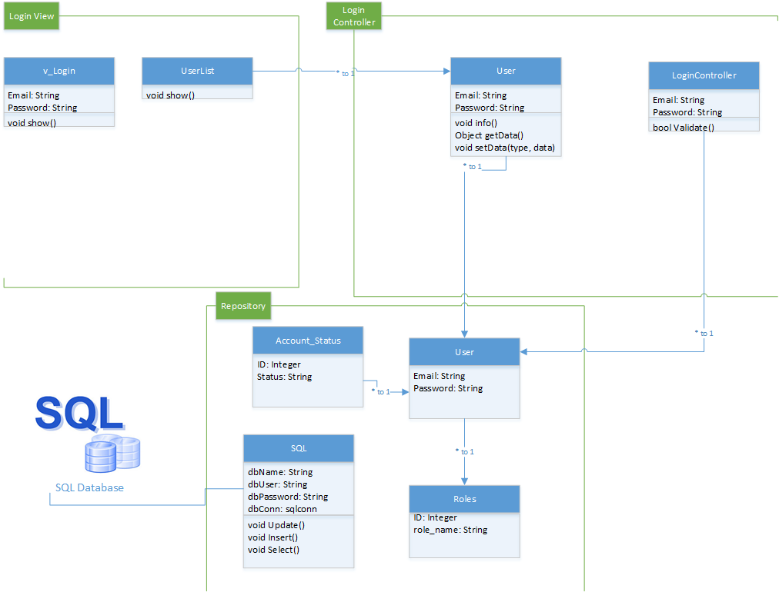

## Figure 9 - User Story # 872 Class Diagram

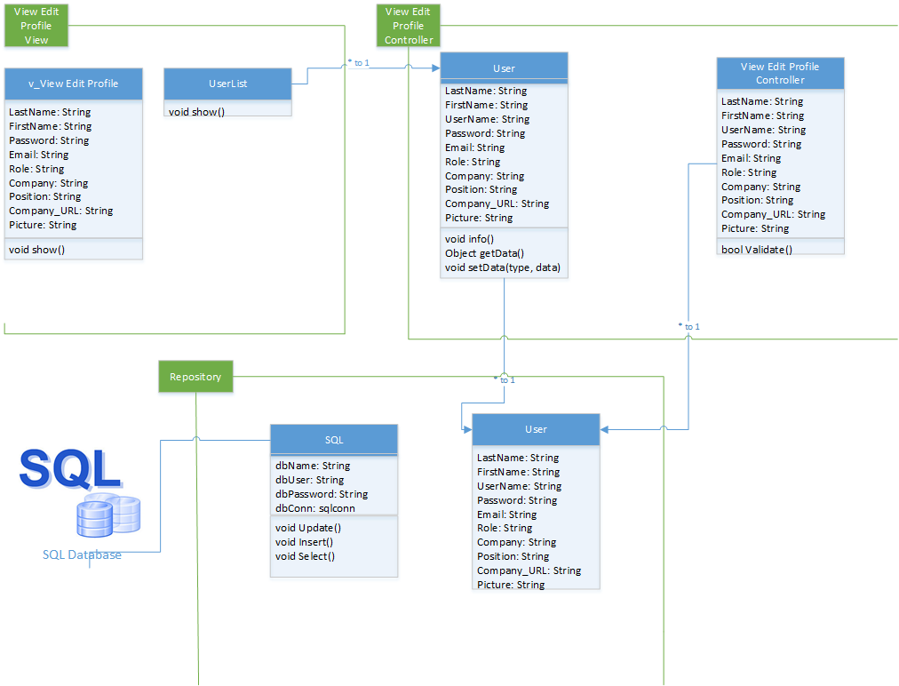

## Figure 10 - User Story # 885 Class Diagram

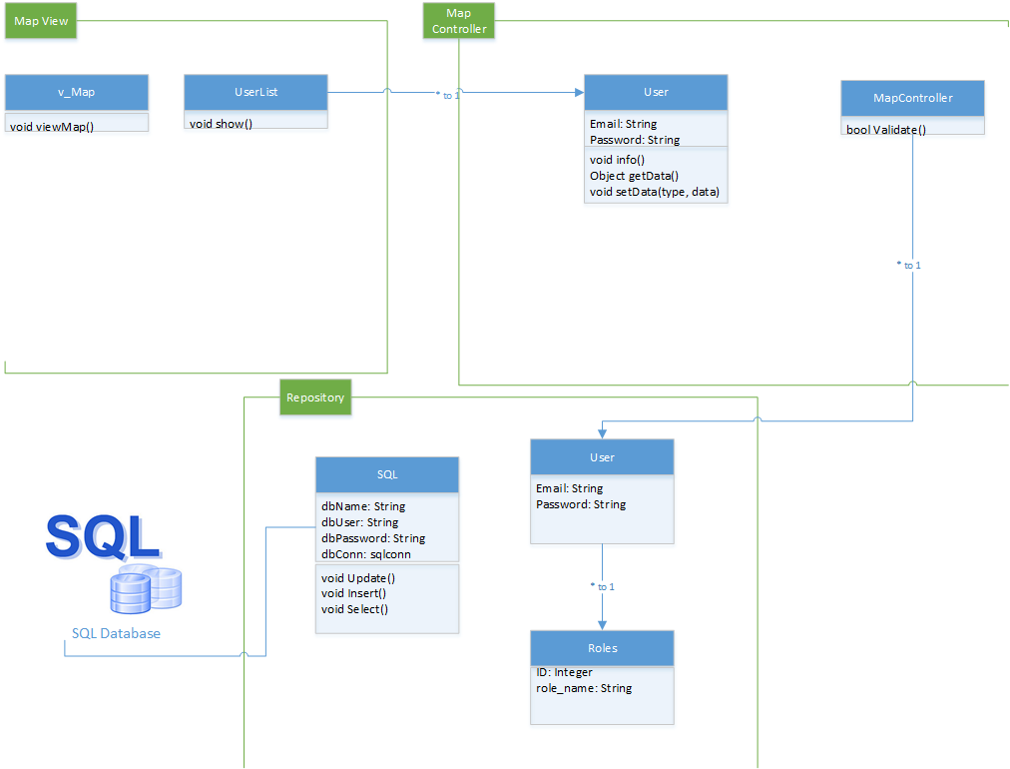

## Figure 11 - User Story # 888 Class Diagram

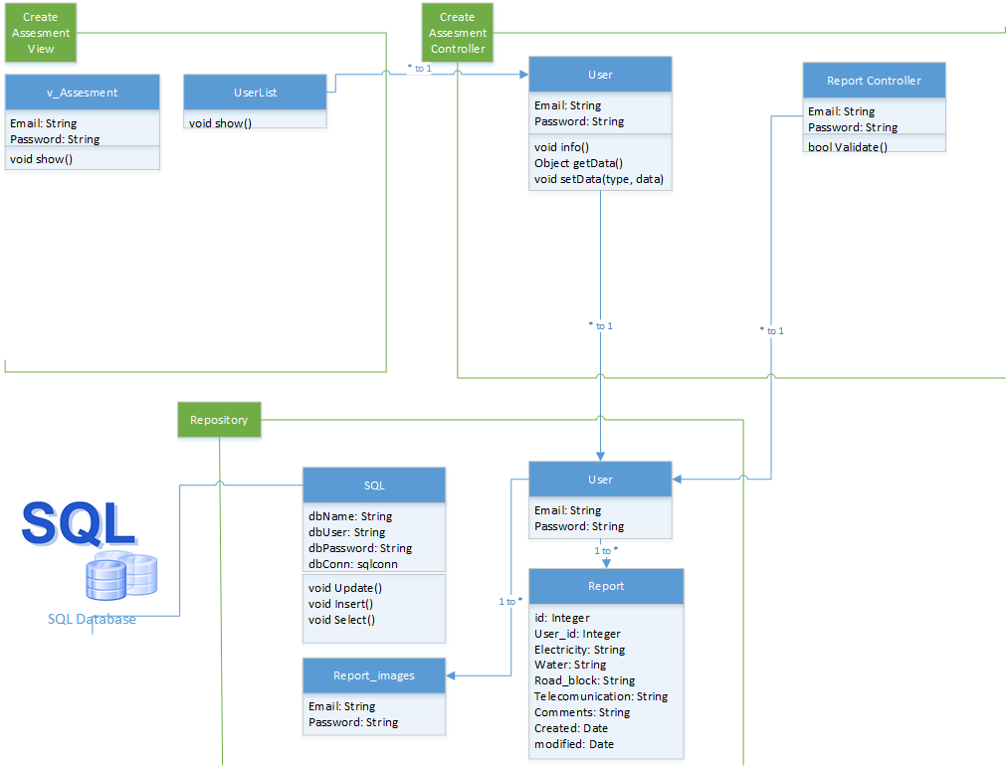

## Figure 12 - User Story # 890 Class Diagram

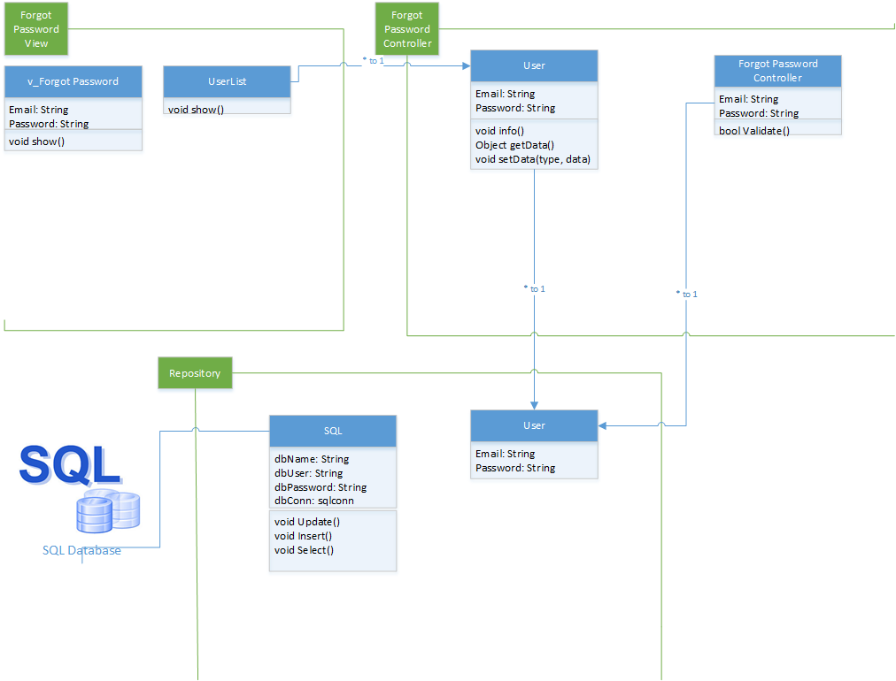

## Figure 13 - User Story # 904 Class Diagram

View Map Marker Class Diagram.png

## Figure 14 - User Story # 891 Class Diagram

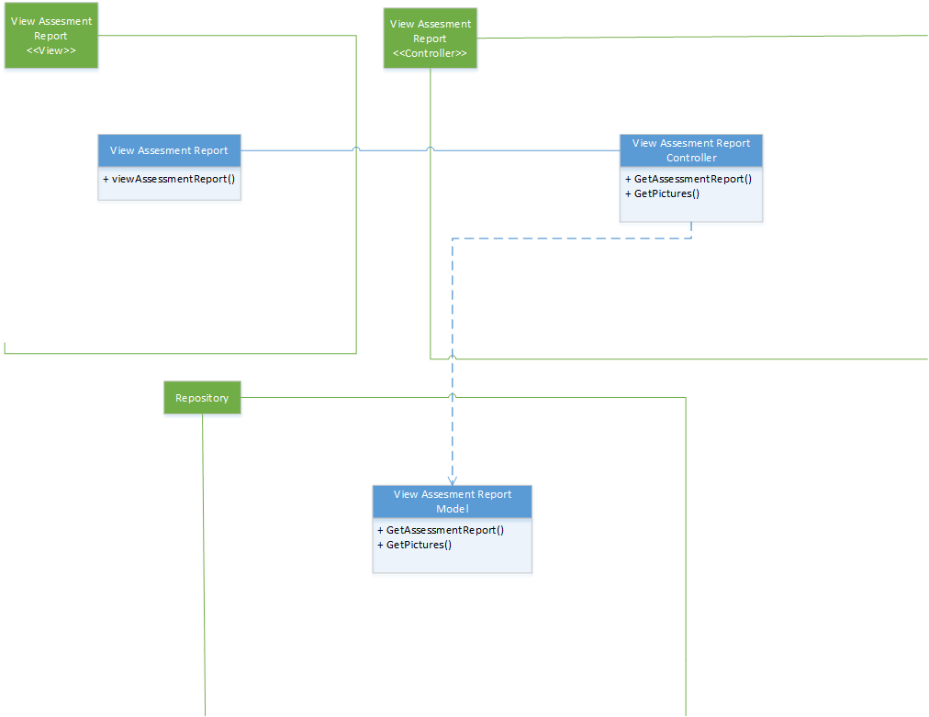

## Figure 15 - User Story # 908 Class Diagram

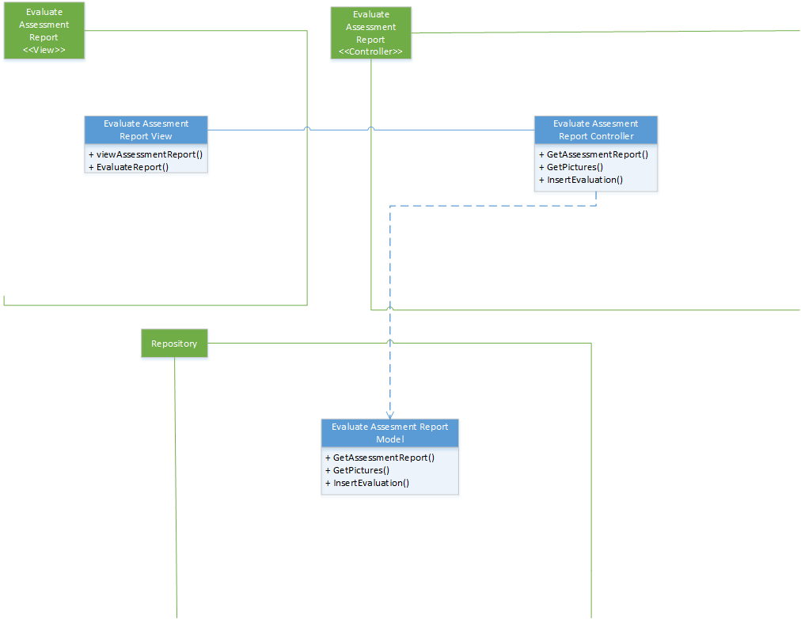

## Figure 16 - User Story # 914 Class Diagram

Filter Map Marker Class Diagram.png

## Figure 17 - User Story # 917 Class Diagram

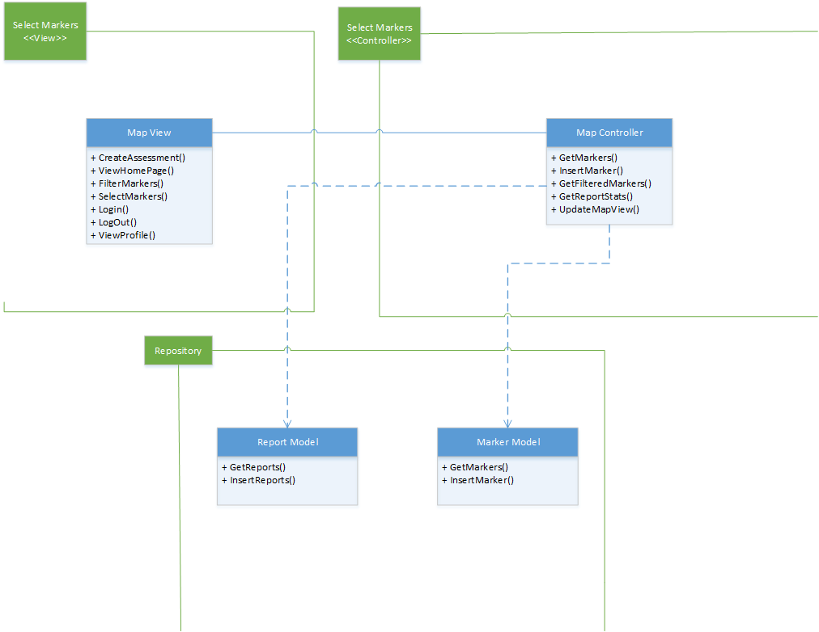

## Figure 18 - User Story # 897 Class Diagram

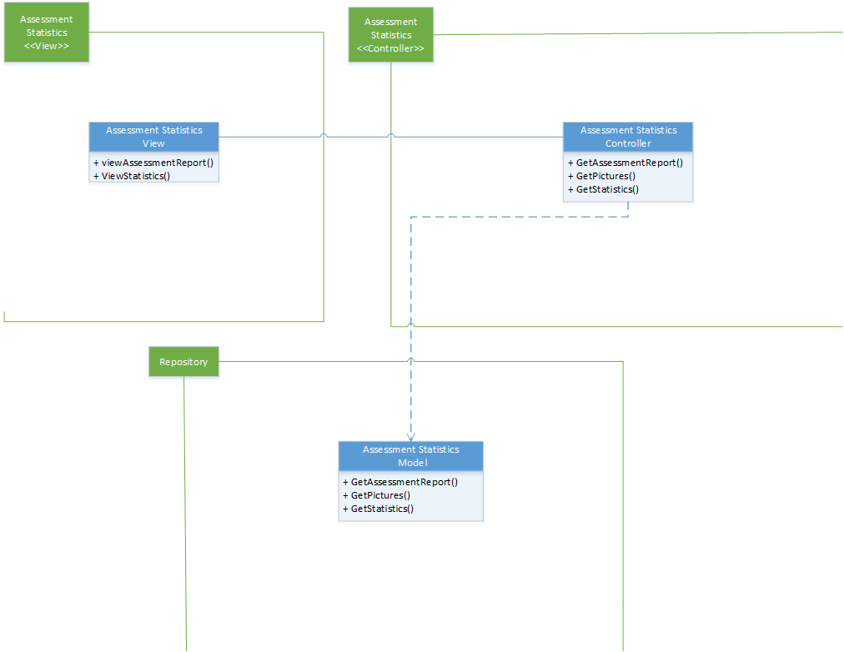

## Figure 19 - User Story # 898 Class Diagram

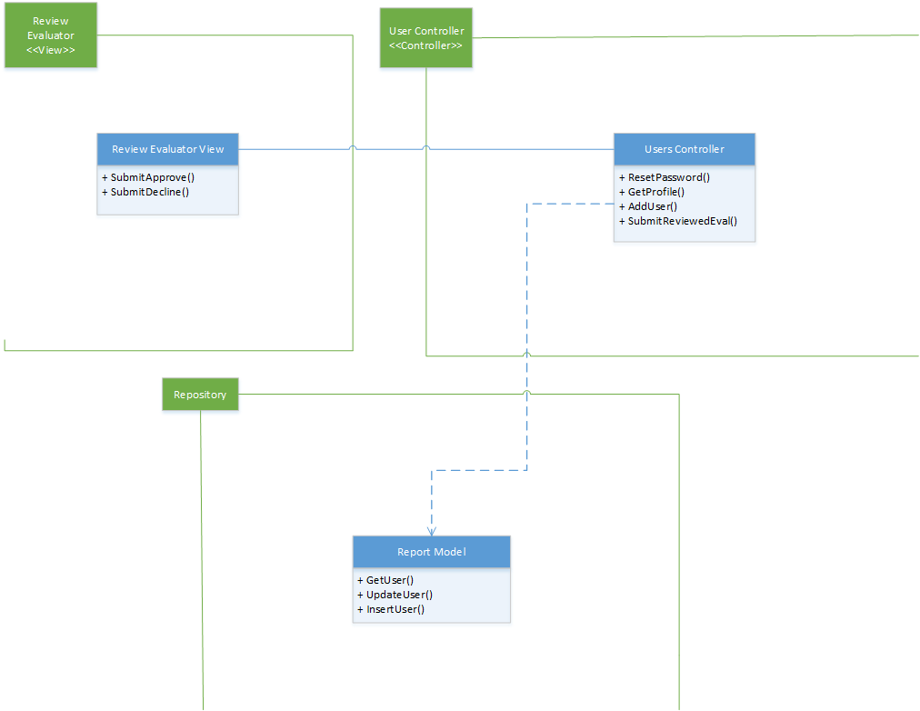

## Figure 20- User Story # 919 Class Diagram

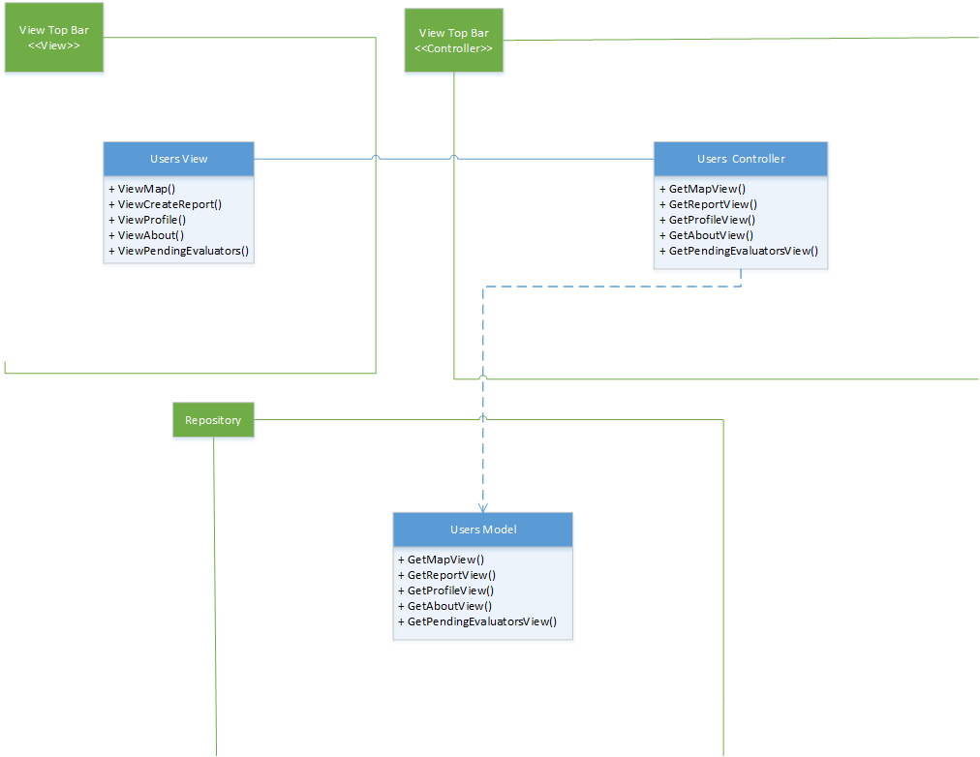

## Figure 21- User Story # 928 Class Diagram

### Dynamic UML Diagrams

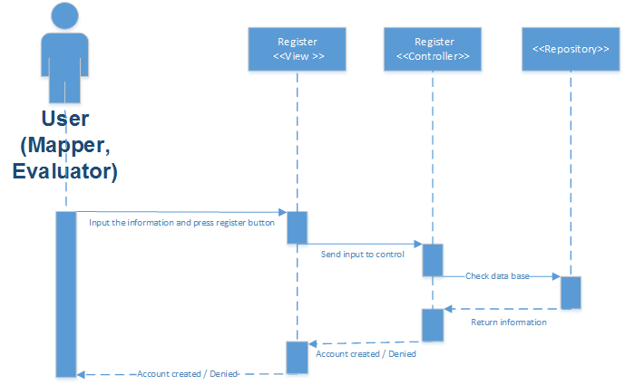

## Figure 1- User Story # 871 Sequence Diagram

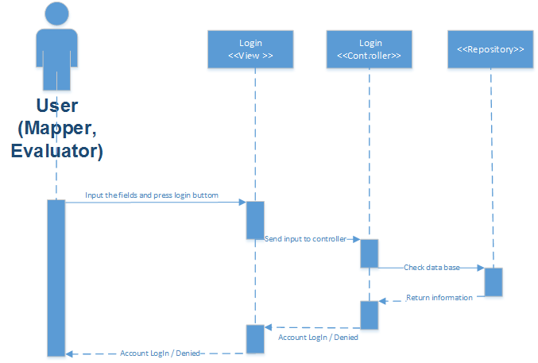

## Figure 2- User Story # 872 Sequence Diagram

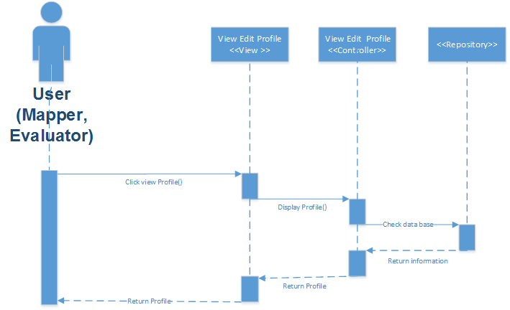

## Figure 3- User Story # 885 Sequence Diagram

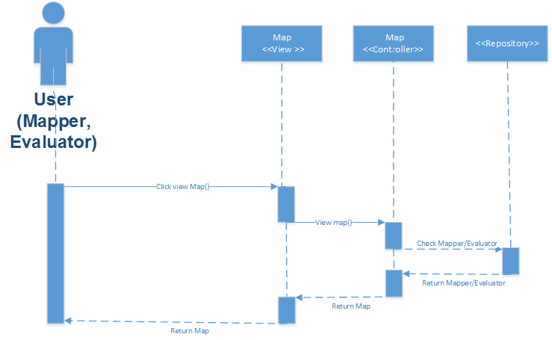

## Figure 4- User Story # 888 Sequence Diagram

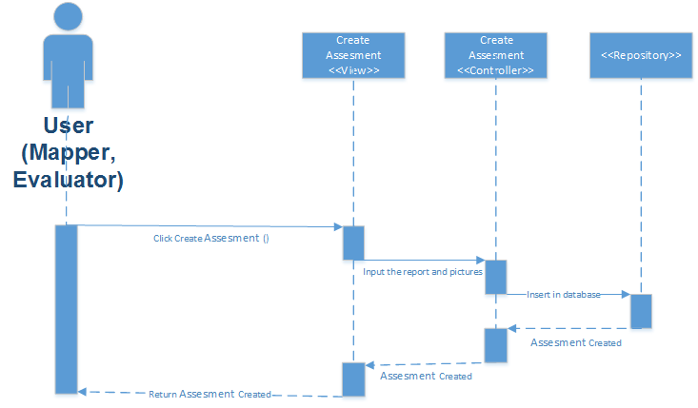

## Figure 5- User Story # 890 Sequence Diagram

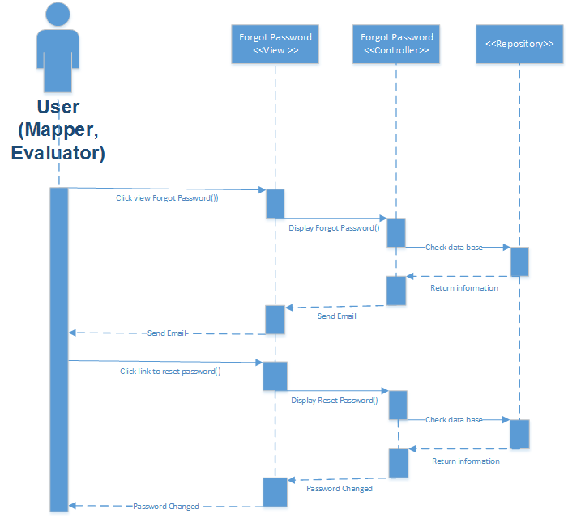

## Figure 6- User Story # 904 Sequence Diagram

View Map Marker-Sequence Diagram.png

## Figure 7- User Story # 891 Sequence Diagram

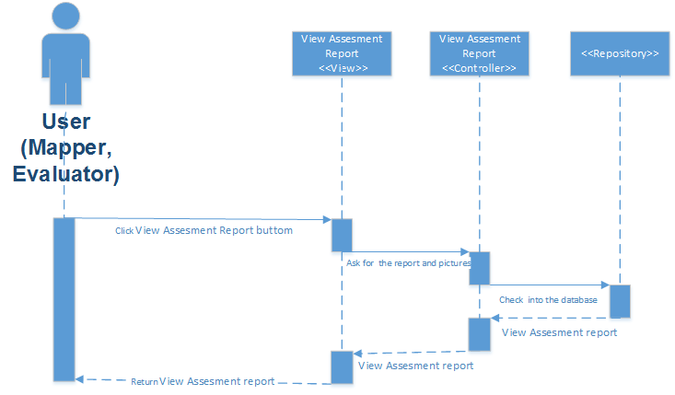

## Figure 8- User Story # 908 Sequence Diagram

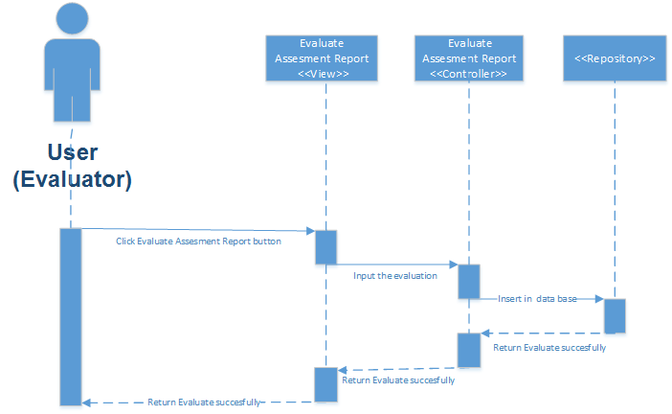

## Figure 9- User Story # 914 Sequence Diagram

Filter Map Marker-Sequence Diagram.png

## Figure 10- User Story # 917 Sequence Diagram

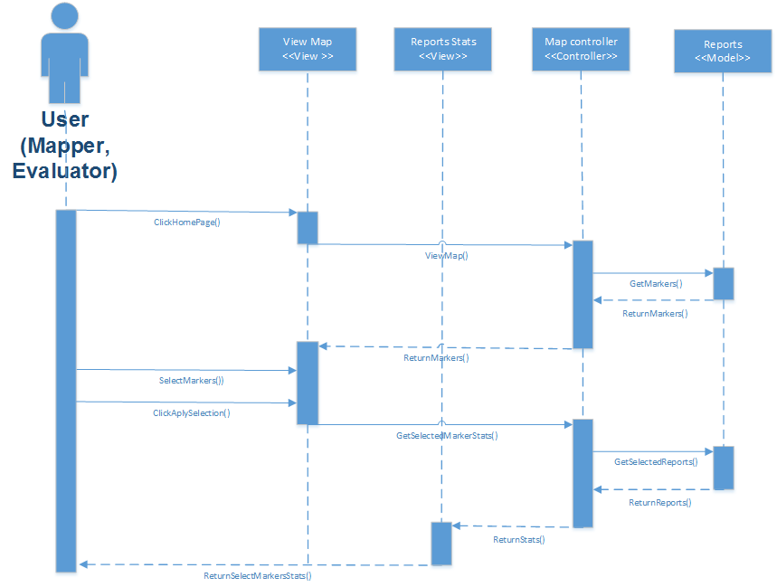

## Figure 11- User Story # 897 Sequence Diagram

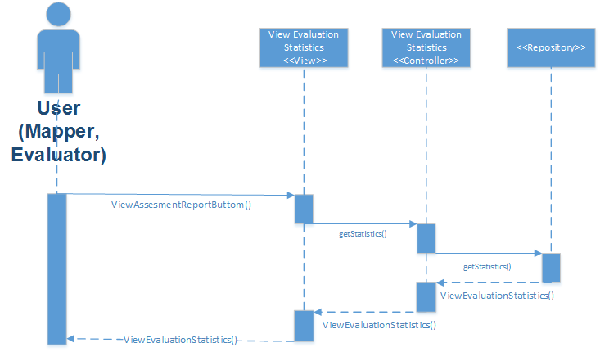

## Figure 12- User Story # 898 Sequence Diagram

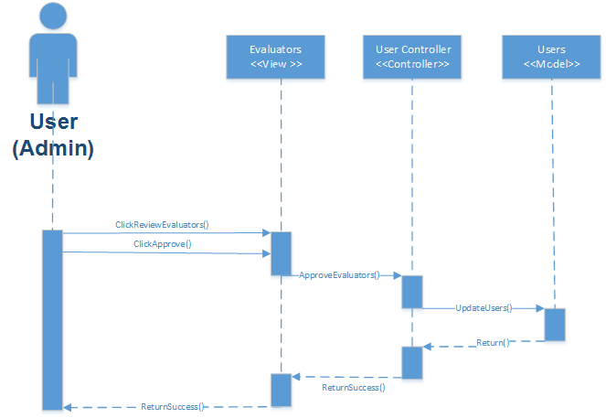

## Figure 13- User Story # 919 Sequence Diagram

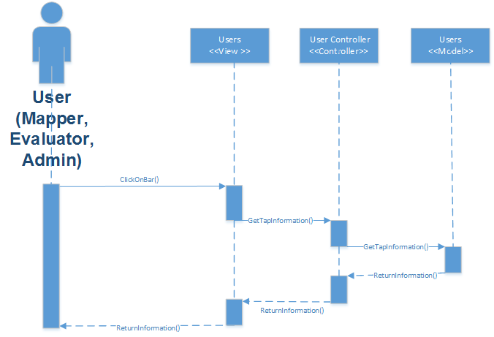

## Figure 14- User Story # 928 Sequence Diagram



## Figure 9- User Story # 914 Sequence Diagram

## Appendix B - User Interface Design

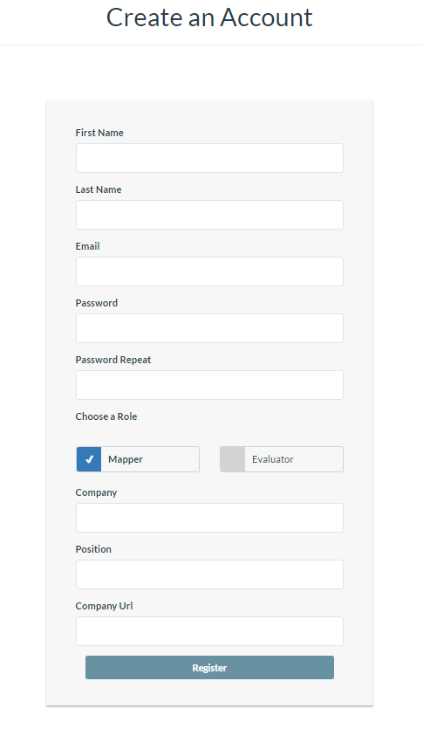

## Figure 1- Register

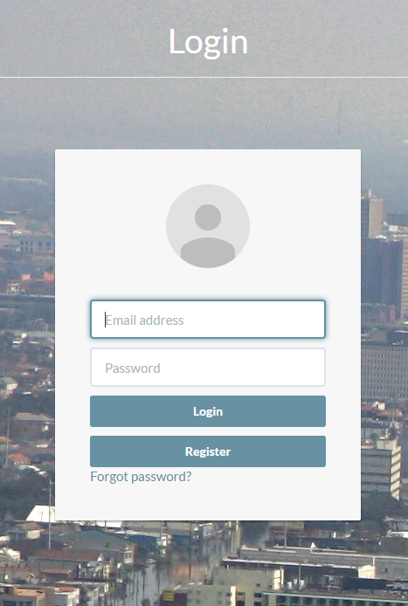

## Figure 2- Login

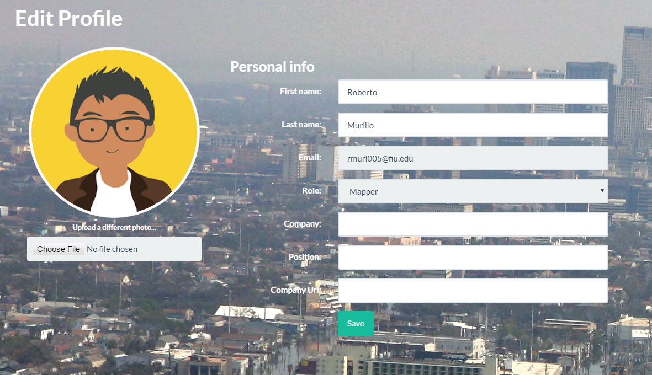

## Figure 3- Edit Profile

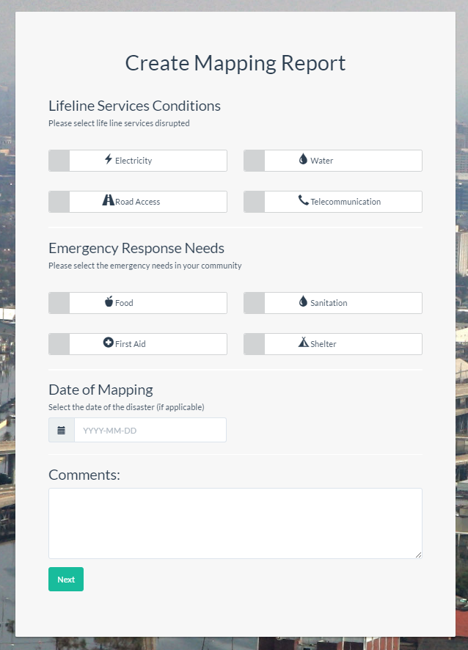

## Figure 4- Create Mapping Report

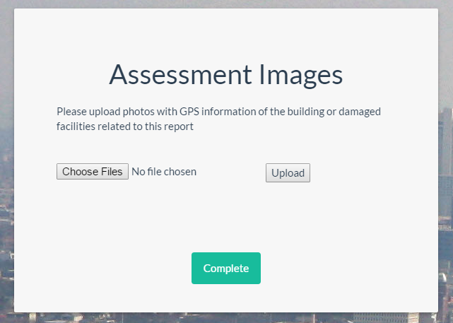

## Figure 5- Create Mapping Report Pictures

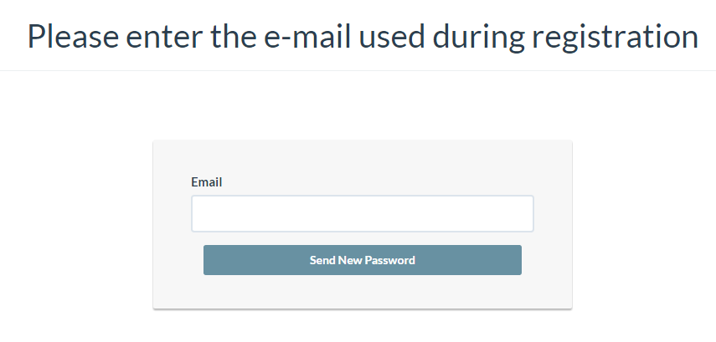

## Figure 6- Reset Password

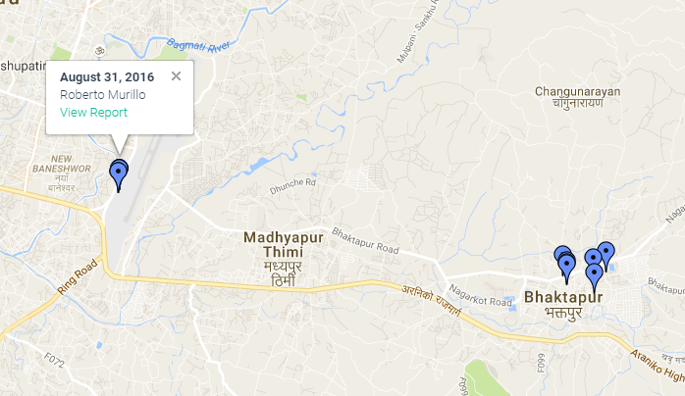

## Figure 7- Map Markers

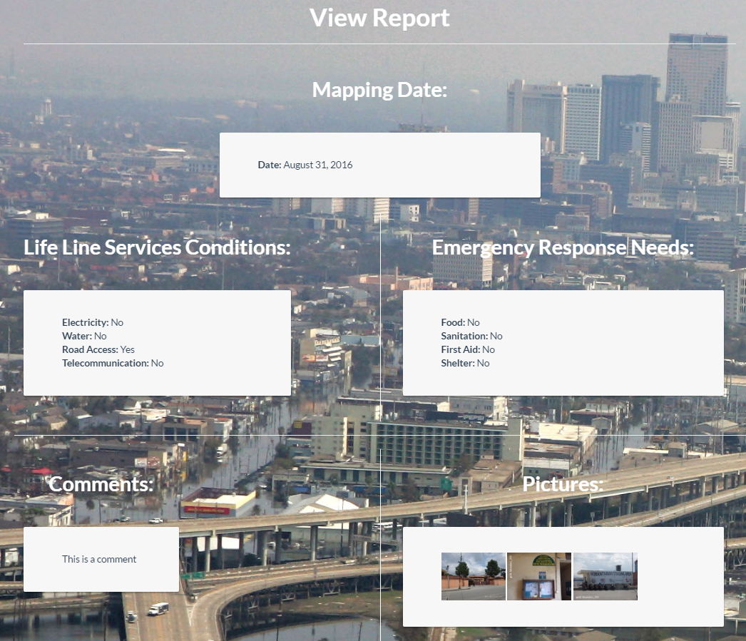

## Figure 8- View Report

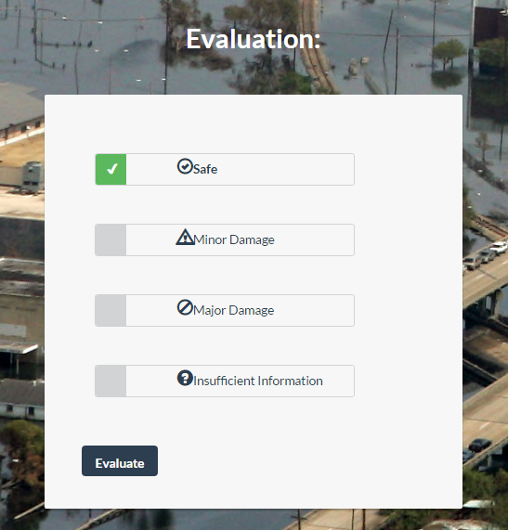

## Figure 9- Evaluate Report

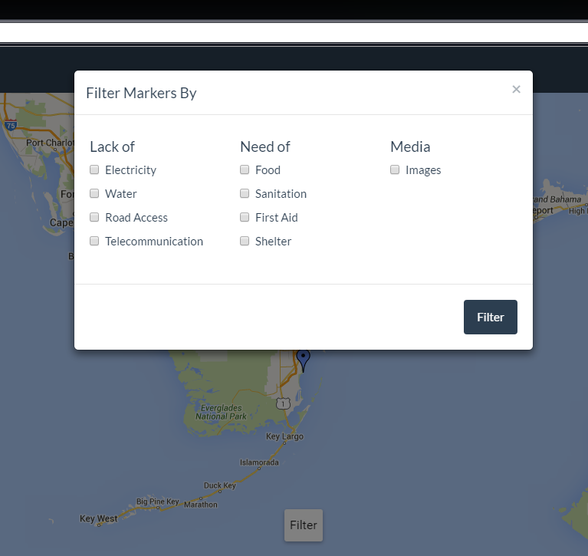

## Figure 10- Filter The Markers

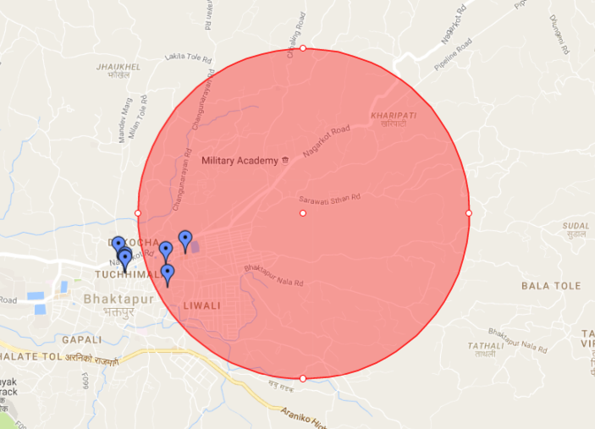

## Figure 11- Selection of The Markers

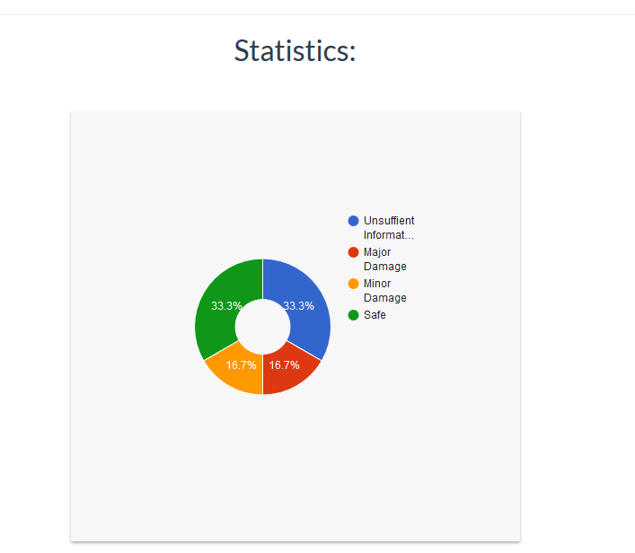

## Figure 11- Statistics for Report

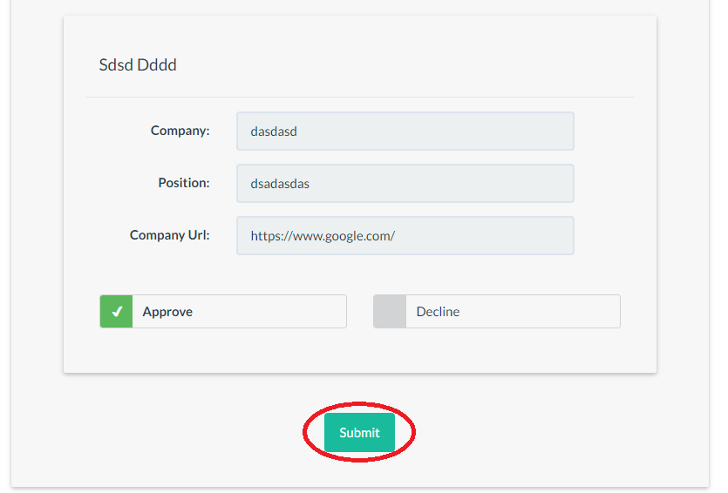

## Figure 12- Review Evaluators

## Appendix C - Sprint Review Reports

## 

## Sprint 1 Report

## Attendees: <Yonicel Leyva, Roberto Murillo, Ali Mustafavi>

Start time: <4:30 PM>

End time: <9:30 PM>

After discussion, the velocity of the team were estimated to be 30.

The product owner chose the following user stories to be done during the next sprint. They are ordered based on their priority.

* Create Database
* Create Register backend
* Create Login backend
* Create Register UI
* Create Login UI

The team members indicated their willingness to work on the following user stories.

* <Roberto Murillo>
* Create Register UI
* Create Login UI
* <Yonicel Leyva>
* Create Database:
  + Account=>email/username,password,organization,name,lname
* Create Register backend
* Create Login backend

## Sprint 2 Report

Attendees: <Yonicel Leyva, Roberto Murillo, Ali Mustafavi>

Start time: <4:30 PM>

End time: <9:30 PM>

After discussion, the velocity of the team were estimated to be 36.

The product owner chose the following user stories to be done during the next sprint. They are ordered based on their priority.

* Homepage with google map
* Report building hazard form
* View profile
* Forgot password

The team members indicated their willingness to work on the following user stories.

* <Roberto Murillo>
* Homepage with google map
* Forgot password
* <Yonicel Leyva>
* Report building hazard form
* View profile

## 

## Sprint 3 Report

Attendees: <Yonicel Leyva, Roberto Murillo, Ali Mustafavi>

Start time: <5:30 PM>

End time: <6:00 PM>

After discussion, the velocity of the team were estimated to be 24.

The product owner chose the following user stories to be done during the next sprint. They are ordered based on their priority.

* View map marker
* View assessment report
* Evaluate assessment report
* Filter map markers

The team members indicated their willingness to work on the following user stories.

* <Roberto Murillo>
* View assessment report
* Evaluate assessment report
* <Yonicel Leyva>
* View map marker
* Filter map markers

## Sprint 4 Report

Attendees: <Yonicel Leyva, Roberto Murillo, Ali Mustafavi>

Start time: <5:30 PM>

End time: <6:00 PM>

After discussion, the velocity of the team were estimated to be 25.

The product owner chose the following user stories to be done during the next sprint. They are ordered based on their priority.

* Assessment statistics
* Map selection

The team members indicated their willingness to work on the following user stories.

* <Roberto Murillo>
* Assessment statistics
* Bug fix: Fix assessment evaluation privileg
* Bug fix: Fix choices for evaluation
* <Yonicel Leyva>
* Map selection
* Bug fix: Fix create assessment

## Sprint 5 Report

Attendees: <Yonicel Leyva, Roberto Murillo, Ali Mustafavi>  
Start time: <5:30 PM>  
End time: <6:00 PM>  
  
After discussion, the velocity of the team were estimated to be 23.  
  
The product owner chose the following user stories to be done during the next sprint. They are ordered based on their priority.  
  
Customize top bar with logo

Review Evaluator  
  
The team members indicated their willingness to work on the following user stories.

* <Roberto Murillo>
* Assessment statistics
* Customize top bar with logo
* Add date to the report view
* <Yonicel Leyva>
* Review Evaluator

## 

## 

## 

## 

## Appendix D - Sprint Retrospective Reports

**Sprint 1 Retrospective**

Attendees: Yonicel Leyva,Roberto Murillo

Start time: 4:30 PM

End time: 9:30 PM

What went wrong?

* Did we do a good job estimating our team's velocity?
  + We were close estimating the velocity. But ultimately we were able to do 25 from the committed 30.
* Did we do a good job estimating the points (time required) for each user story?
  + The points assigned for the stories in this sprint were underestimated. We took longer working on the stories.
* Did each team member work as scheduled?
  + Yes

What went right?

* Completing most of the committed stories

How to address the issues in the next sprint?

* How to improve the process?
  + Do a better job estimating the points for the stories.
* How to improve the product?
  + Increasing our velocity and committing to more stories to add more features.

**Sprint 2 Retrospective**

Attendees: Yonicel Leyva,Roberto Murillo

Start time: 8:30 PM

End time: 9:30 PM

What went wrong?

* Did we do a good job estimating our team's velocity?
  + We overestimated the team’s velocity by 6 points. Our actual velocity was 30.
* Did we do a good job estimating the points (time required) for each user story?
  + For most of the user stories we were accurate, however for the reset password story we overestimated the points.
* Did each team member work as scheduled?
  + Yes

What went right?

* The team was able to complete all tasks assigned.

How to address the issues in the next sprint?

* How to improve the process?
  + Do a better job estimating the points for the stories.
* How to improve the product?
  + Increasing our velocity and committing to more stories to add more features.

**Sprint 3 Retrospective**

Attendees: Yonicel Leyva,Roberto Murillo

Start time: 8:30 PM

End time: 9:30 PM

What went wrong?

* Did we do a good job estimating our team's velocity?
  + Yes we finished it on time
* Did we do a good job estimating the points (time required) for each user story?
  + Yes we did
* Did each team member work as scheduled?
  + Yes

What went right?

* The team was able to complete all tasks assigned.

How to address the issues in the next sprint?

* How to improve the process?
  + Do a better job estimating the points for the stories.
* How to improve the product?
  + Increasing our velocity and committing to more stories to add more features.

**Sprint 4 Retrospective**

Attendees: Yonicel Leyva,Roberto Murillo

Start time: 10:00 PM

End time: 10:30 PM

What went wrong?

* Did we do a good job estimating our team's velocity?
  + Yes we finished it on time
* Did we do a good job estimating the points (time required) for each user story?
  + Yes we did
* Did each team member work as scheduled?
  + Yes

What went right?

* The team was able to complete all tasks assigned.

How to address the issues in the next sprint?

* How to improve the process?
  + Do a better job estimating the points for the stories.
* How to improve the product?
  + Increasing our velocity and committing to more stories to add more features.

**Sprint 5 Retrospective**

Attendees: Yonicel Leyva,Roberto Murillo

Start time: 10:00 PM

End time: 10:30 PM

What went wrong?

* Did we do a good job estimating our team's velocity?
  + Yes we finished it on time
* Did we do a good job estimating the points (time required) for each user story?
  + Yes we did
* Did each team member work as scheduled?
  + Yes

What went right?

* The team was able to complete all tasks assigned.

How to address the issues in the next sprint?

* How to improve the process?
  + Do a better job estimating the points for the stories.
* How to improve the product?
  + Increasing our velocity and committing to more stories to add more features.

# References

The teachings of Masoud Sajadi and Mohsen Taheri was crucial in the making of this report. The guidance of our product owner and mentor Ali Mostafavi was paramount to the analysis and understanding of the existing system.